**Northeastern University**

Cloud Computing Team Report

**6225-CSYE Network Structures and cloud computing with *Prof. Julian Cooper***

**- (Team 4), 04/21/2015**

*Amey Kelekar, Dhawal Vora, Smeet Kothari, Loukik Kulkarni, Dev Khimasia*

|  |
| --- |
| ***Table of Contents*** |
| **1. *Business Justification , Systems and descriptions****.........................................................****3*** |
| **2. *Visio Diagram****.................................................................................................................6* |
| **3. *Cost vs Performance****.......................................................................................................****6*** |
| **4. *Disaster Recovery procedures*** *.......................................................................................7* |
|  |

1. **Business justification *, Systems and descriptions* ** Amazon Web Services is a collection of remote computing services that together make up a cloud computing platform, offered over internet by amazon.com.  
   Amazon Elastic Compute Cloud (Amazon EC2) is a web service that provides resizable compute capacity in th cloud. It is designed to make web-scale cloud computing easier for developers.   
     
   **Overview:**  
   We have created a Blackboard Web Application where in Students can login into the portal and upload their Assignments. Entire stack is on AWS EC2 Instance and the backend generated data stored in RDS and backend application is done in Java Spring MVC.   
   Students can upload Assignments on the portalwherein the Assignments are saved on S3 bucket in AWS through Hibernate.

**Mission:**

Our goal is to develop and deploy a web application that simulates workloads on servers

and scale them accordingly using AWS.

Simulate the web application on EC2 Instance and configure it to connect to RDS for MySQL database Instance.

Develop 5 use case buttons to simulate increasing load on the application using Java Spring framework.

**AWS Components:**

Compute: EC2 Instance

Storage and Content Delivery: S3 Bucket

Database: RDS

Networking: VPC (Scenario1)

**EC2 Instance:**

Our Architecture consist of 2 Instances one is Master and other is Slave both are t2.micro.

Master Instance runs all the Python Scripts where in we installed urllib, varlib etc on the Instance.

Slave Instance is the one which balances the load and auto scales whenever necessary.

We installed Tomcat7 on Slave Instance. SSL certification, setting up JAVA_HOME is all done on this Instance.

**S3 Bucket:**

Amazon S3 is Object Storage Mechanism.

In Our Architecture we have created two S3 buckets wherein Assignments get stored in one bucket and the generated reports gets stored in another bucket.

3 types of S3 buckets are available that is S3 Standard (frequently used), S3 Standard (infrequently used) and Amazon Glaciers.

We have used Standard frequently used S3 bucket which has 5GB standard storage.

S3 replicates data on multiple devices automatically in different availability zones.

**Relational Database Services:**

We have used RDS for MySQL Database Instance to fetch the data for our Application.

We have also taken a snapshot of the RDS in case if we want to restore or migrate the

database.

**VPC (Scenario 1):**

Virtual Private Cloud(VPC) can be of 4 scenarios. We have used Scenario 1 which is default one (VPC with a Single Public Subnet)

**Flowchart of our Simulatuon:**



1. **Visio diagram**



1. **Cost vs Performance**

* Cost Explorer is a free tool that you can use to view graphs of your costs (also known as spend data) for up to the last 13 months, and forecast how much you are likely to spend for the next three months.
* Cost Explorer is used to see which service you can use the most, which AZ most of the traffic is in.
* Cost Explorer can be used to filter your view by a variety of filters.
* Forecasting with Cost Explorer:
  + A forecast is a prediction of how much you will use AWS over the next three months, based on your past usage.
  + Different ranges of accuracy have different confidence intervals.
  + For Example, if your budget is set to 100$ and you used 75$ in past 3 weeks. So cost Explorer forecasts that there is an 80% probability that your billed costs will be in the $ 90-100 range, and an 95% probability that your billed costs will be into $ 80-110 range.
* Plot Graph:   
   There are two sets of lines on either side of your costs line. The pair of lines that are closest to the cost line indicate the 80% confidence interval, and the pair of lines that are furthest from the cost line indicate the 95% confidence interval. The wider the range included in the forecast, the higher the probability that your bill will fall in the forecasted range.
* Bar Graph: There are two sets of lines on either side of the top of your bar. The closer darker lines indicate the 80% confidence interval, and the further, fainter lines indicate the 95% confidence interval. The wider the range included in the forecast, the higher the probability that your bill will fall in the forecasted range.



1. **Disaster Recovery Procedures**  
     
   **Preparing for and recovering from a disaster** - hardware or software failure network outage  
    - power outage  
    - physical damage  
    - human error  
     
   **Ensure business continuity during a DR event**   
    - full-scale availability  
    - fault tolerance systems   
     
   **Recovery Time Objective & Point Objective**   
    - Preparing for and recovering from a disaster  
    - RTO- The time it takes to restore a business process to its service level   
    - RPO- The system should recover all data that was in the system a defined time   
    - The company determines financial impact by considering many factors, such as the loss of business and damage to its reputation due to downtime and the lack of systems availability.  
     
   **DR Investment Practices**  
    - Off-site duplication of data and infrastructure  
    - The disaster recovery environment’s location and the source infrastructure should be a significant physical distance apart  
    - Isolate from faults that could impact the source site  
     
   **AWS Services for Disaster Recovery**  
    Regions  
    - Americas, EMEA, and Asia Pacific  
    - Regions consist of one or more Availability Zones.   
    Storage  
    - Amazon S3:  
    Objects are redundantly stored on multiple devices across multiple facilities within a region, designed to provide a durability of 99.999999999%   
    - AWS Import/Export:  
    AWS Import/Export bypasses the Internet and your data directly onto and off of storage devices by of the high-speed internal network of Amazon.  
      
    For data sets of significant size, AWS Import/Export is often faster than Internet transfer and more cost than upgrading your connectivity.   
     
    AWS Storage Gateway  
    - connects an on-premises software appliance with cloud-based storage  
    - **Gateway-cached volumes** — You can store your primary data in Amazon S3 and retain your frequently accessed data locally.  
    - **Gateway-stored volumes** — store your primary data locally and asynchronously back up point-in-time snapshots of this data to Amazon S3   
      
    Compute  
    - Amazon EC2  
    rapidly create virtual machines that you can control designed to provide a durability of 99.999999999%   
    - AMI  
    preconfigure with operating systems and some also include application stacks.  
     
    Networking   
    - Amazon Route 53  
    highly available and scalable Domain Name System (DNS) web service global load balancing capabilities failover between multiple DNS endpoints  
    - Elastic IP Address  
    mask instance or AZ failures by remapping public IP address to instances in a particular region  
    pre-allocate some IP addresses for the most critical systems so that their IP addresses are already known before disaster strikes   
    - Elastic Load balancing  
    distributes incoming application traffic Auto Scaling features  
    - Amazon VPC  
    private, isolated section of the AWS cloud as a virtual network  
    Control over  
    - selection of own IP address range  
    - creation of subnets  
    - configuration of route tables and network getaways  
     
    Databases  
    - Amazon RDS  
    Use it to store critical data in preparation phase or store data in recovery - AMI  
    preconfigure with operating systems and some also include application stacks   
     
    Deployment orchestration  
    post-startup software installation /configuration  
    very helpful in the recovery phase, enabling you to create the required set of resources in an automated way  
    AWS CloudFormation- provision resources in orderly and predictable fashion  
     
    Backup and Restore  
    - Amazon S3 is an ideal destination for backup  
    - Transferring data to and from Amazon S3 is typically done through the network, and is therefore accessible from any location   
    - Where retrieval times of several hours are adequate, there is Amazon Glacier  
    - AWS Storage Gateway enables snapshots of your on-premises data volumes to be transparently copied into Amazon S3 for backup.   
    - Storage-cached volumes allow you to store your primary data in Amazon S3, but keep your frequently accessed data local for low-latency access.   
    - with AWS Storage Gateway, you can snapshot the data volumes to give highly durable backup. In the event of DR, you can restore the cache volumes either to a second site running a storage cache gateway or to Amazon EC2.  
    - Back up into Amazon S3   
    Snapshots of Amazon EBS volumes, Amazon RDS databases, and Amazon Redshift data warehouses can be stored in Amazon S3.   
    you can choose to create backup files and copy those to Amazon S3.

**DR: Recovery**

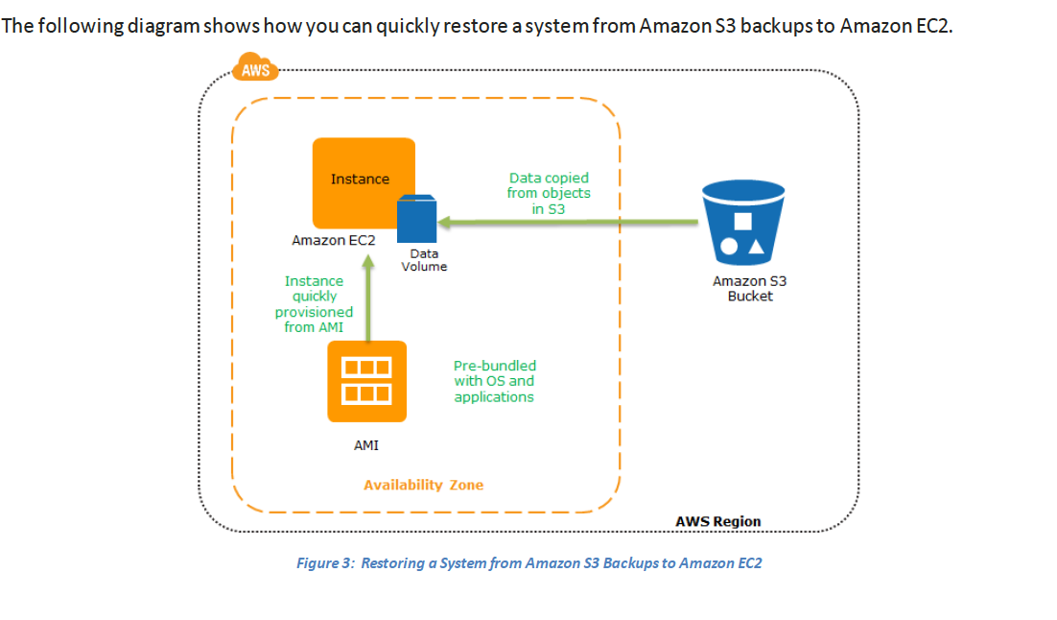

**Pilot Light for Quick Recovery into AWS**

* The term pilot light is often used to describe a DR scenario in which a minimal version of

an environment is always running in the cloud.

* You would typically have some pre-configured servers bundled as Amazon Machine Images (AMIs)
* Use Elastic IP addresses, which can be pre-allocated and identified in the preparation phase for DR, and associate them with your instances.
* Use Elastic Load Balancing (ELB) to distribute traffic to multiple instances. You would then update your DNS records to point at your Amazon EC2 instance or point to your load balancer using a CNAME.
* For less critical systems, you can ensure that you have any installation packages and configuration information available in AWS, for example, in the form of an Amazon EBS snapshot.
* Quicker recovery time method because the core pieces of the system are already running and are continually kept up to date
* Pilot Phase  
  The following figure shows the preparation phase, in which you need to have your regularly changing data replicated to the pilot light, the small core around which the full environment will be started in the recovery phase. Your less frequently updated data, such as operating systems and applications, can be periodically updated and stored as AMIs.  
  Recovery Phase  
  To recover the remainder of the environment around the pilot light, you can start your systems from the AMIs within minutes on the appropriate instance types. For your dynamic data servers, you can resize them to handle production volumes as needed or add capacity accordingly. Horizontal scaling often is the most cost-effective and scalable approach to add capacity to a system. For example, you can add more web servers at peak times. However, you can also choose larger Amazon EC2 instance types, and thus scale vertically for applications such as relational databases. From a networking perspective, any required DNS updates can be done in parallel.
* you need to have your regularly changing data replicated to the pilot light
* 
* Net Earth Chart